# Test 1:

Prediction: 1dAVb

Confidence: 82.8%

Text:

The ECG shows signs of First-degree AV block (1dAVb).

Prolonged PR interval (>200 ms) with normal QRS complex.

Note the longer PR interval in the lead II ECG trace compared to normal.

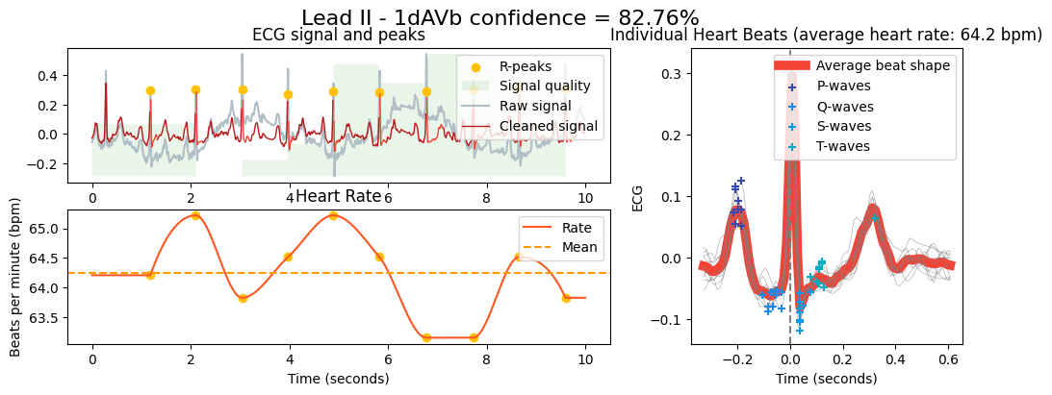

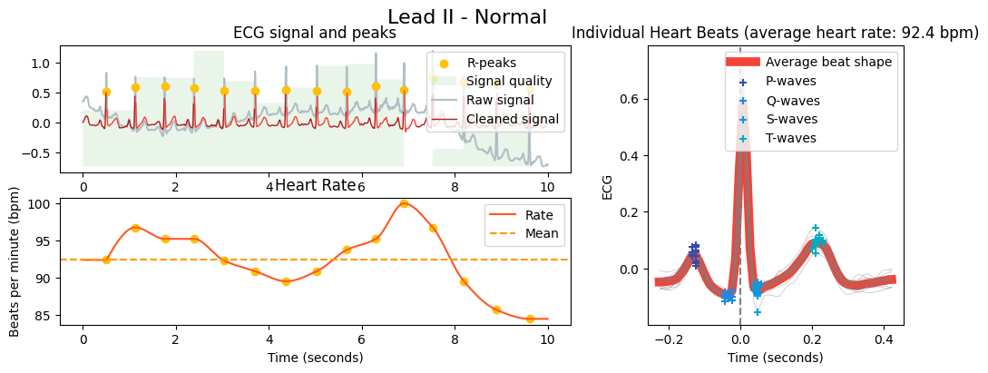

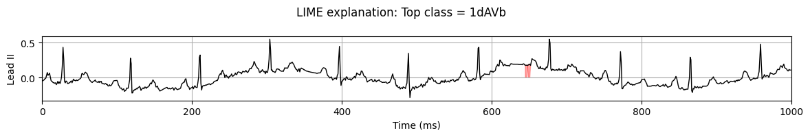

# Test 2:

Prediction: LBBB

Confidence: 99.6%

Text: The ECG shows signs of Left Bundle Branch Block (LBBB).

Wide QRS complex (>120 ms) with a notched or slurred R wave in V5 and V6.

Missing Q wave on lateral leads (I, aVL, V5, V6)

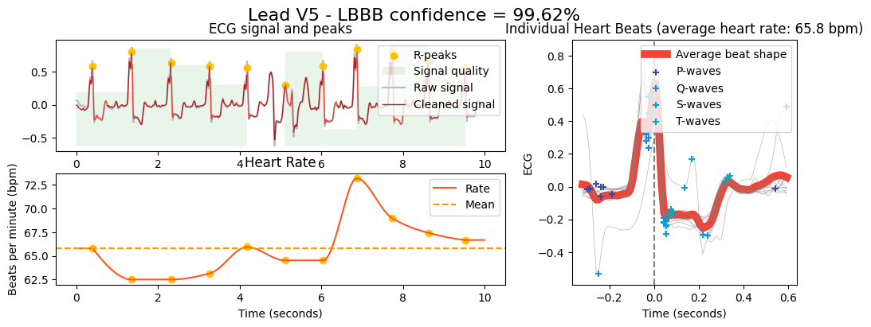

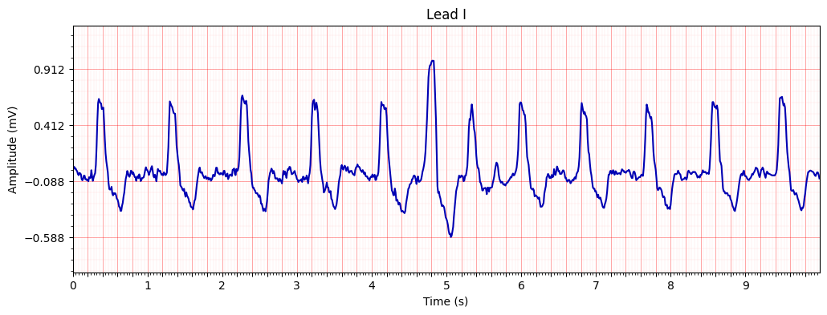

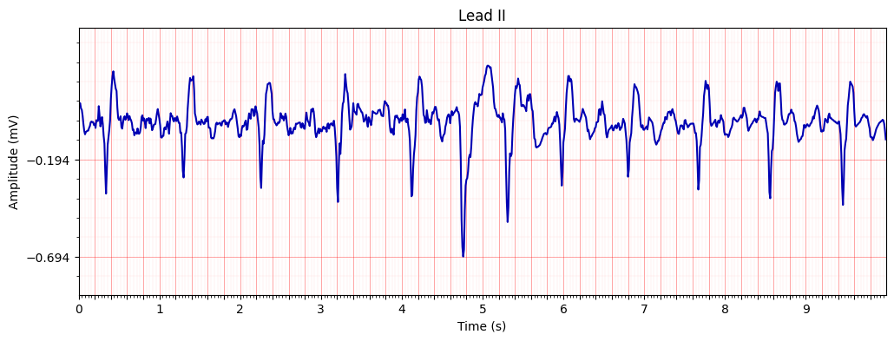

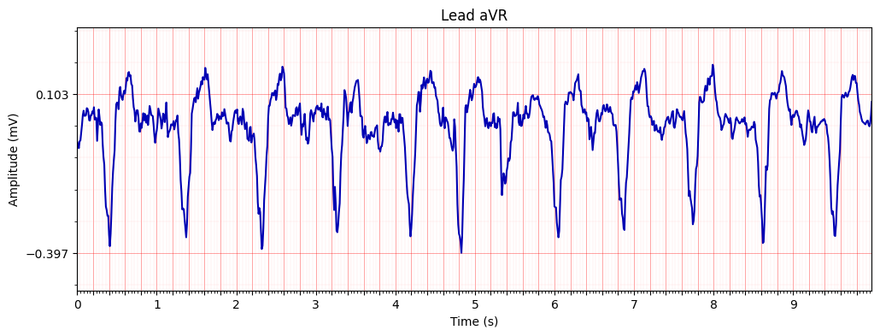

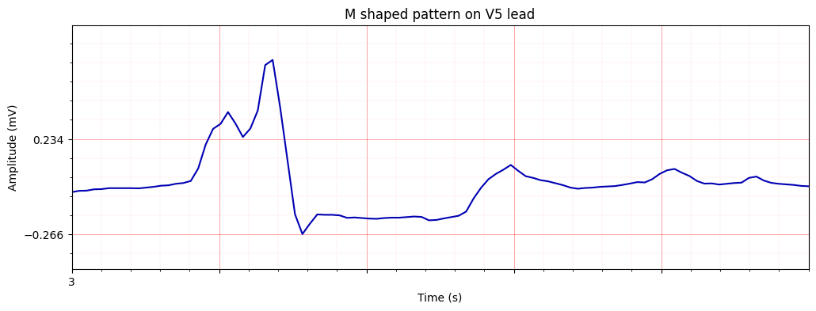

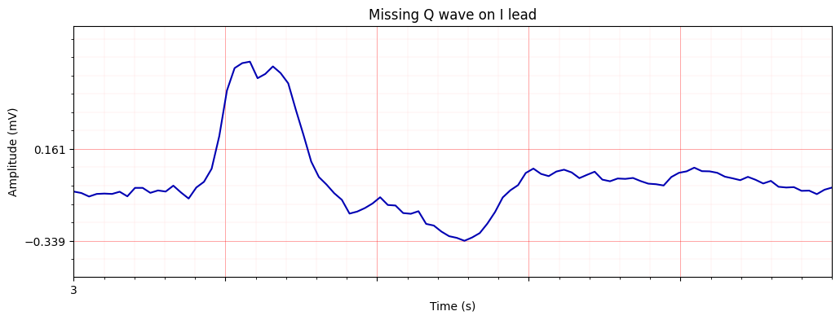

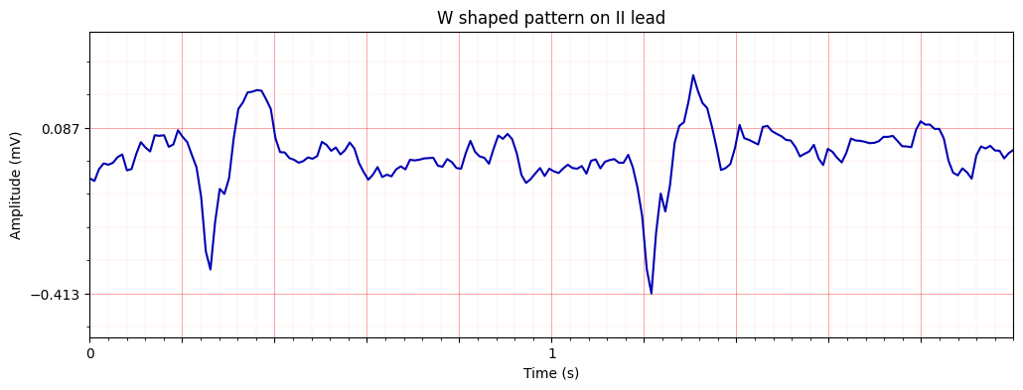

# Test 3:

Prediction: Normal

Confidence: 99.9%

Text: The ECG is normal.

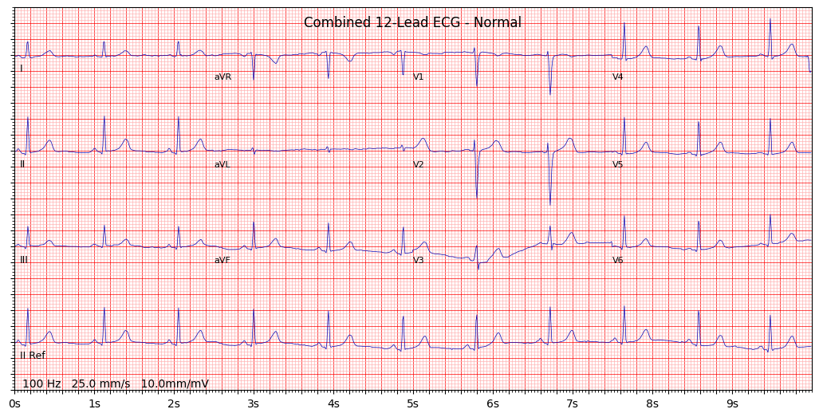

# Test 4:

Prediction: AFLT

Confidence: 99.99%

Text: The ECG shows signs of Atrial Flutter ( AFLT)

Sawtooth pattern in the inferior leads (II, III, aVF) with regular R-R intervals.

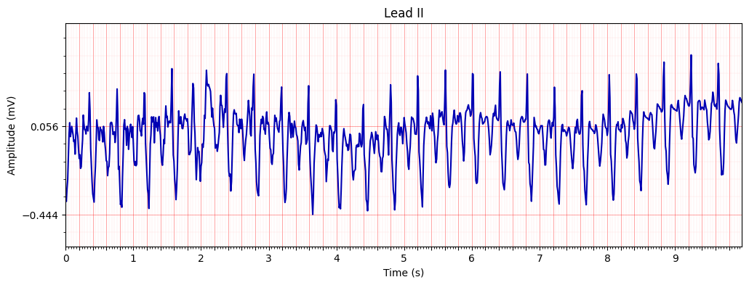

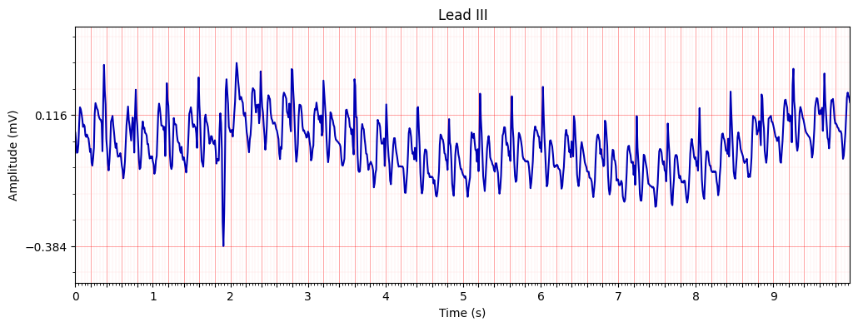

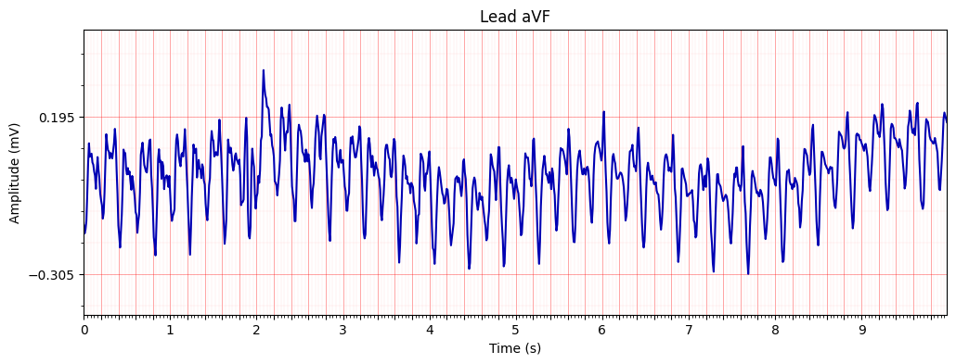

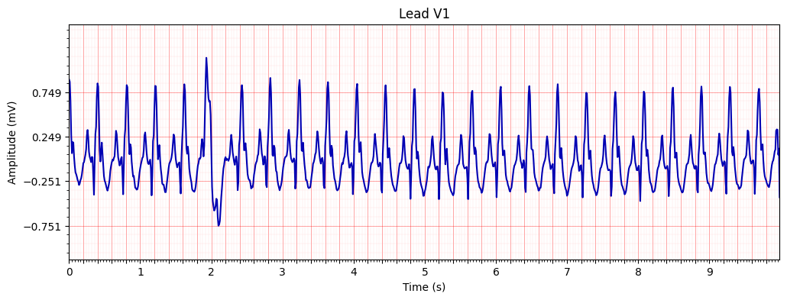

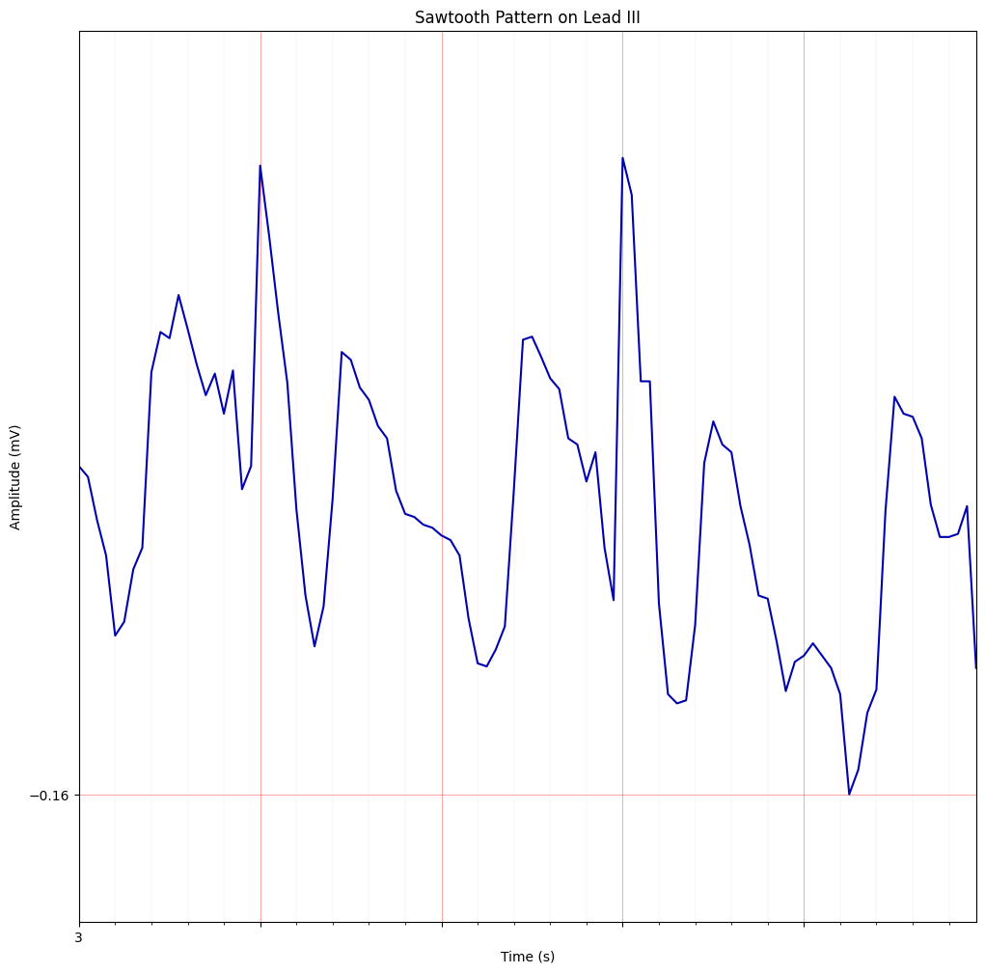

# Test 5:

Prediction: AFIB

Confidence: 99.7%

Text: The ECG shows signs of Atrial Fibrillation (AFIB)

P-wave is absent, and the R-R intervals are irregularly irregular

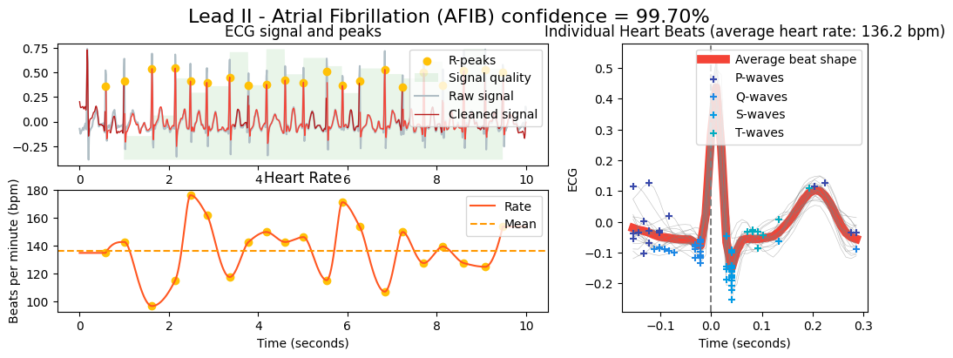

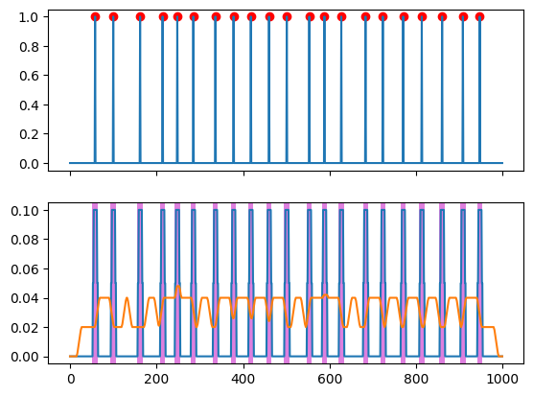

# Test 6:

Prediction: RBBB

Confidence: 99.9%

Text: The ECG shows signs of Right Bundle Branch Block (RBBB).

Wide QRS complex (>120 ms) with an rSR’ pattern in V1 and V2.

Characteristic RSR’ (M-shaped) pattern in V1 and V2 leads.

